Incremental blob to - sql without watermark value

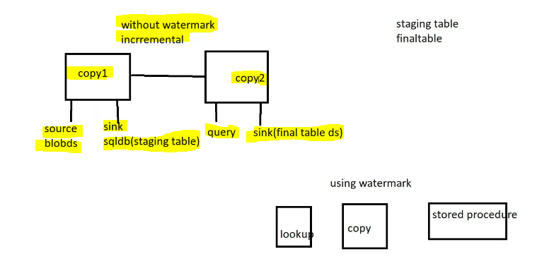
Create blob storage:
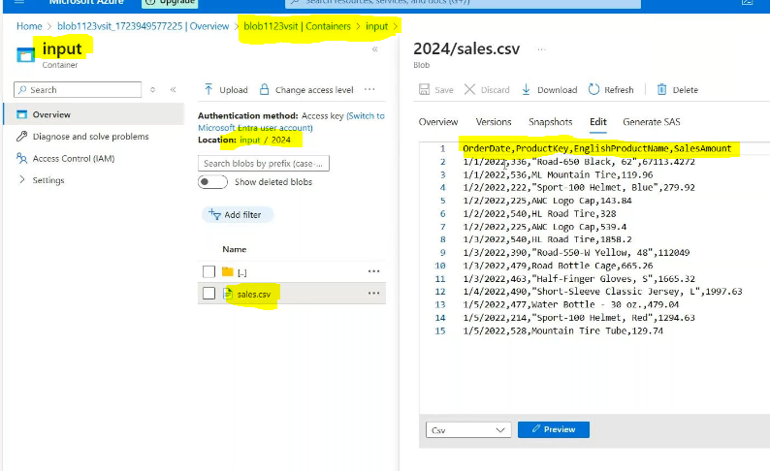
Create database sink side :
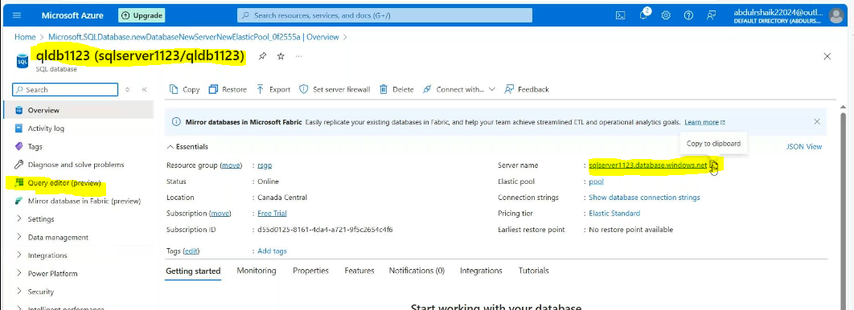
Connected with SSMS:
Create with 2 schema’s here
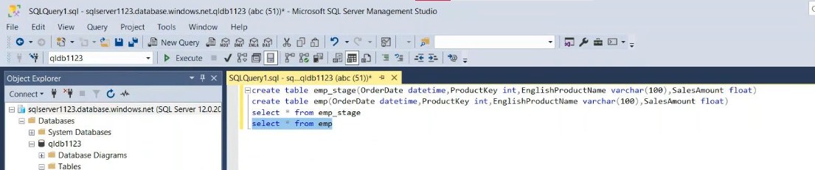
Create linked services for both side:
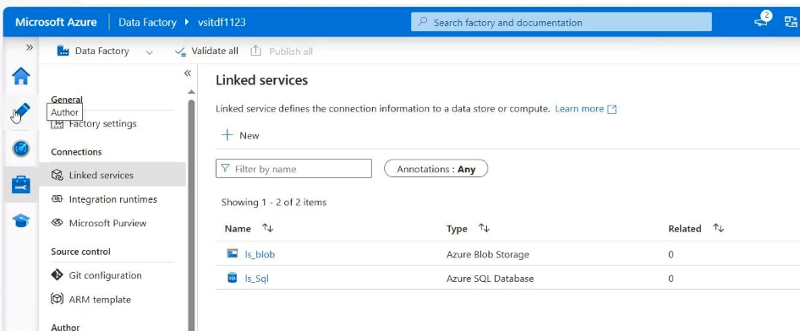
Create dataset for source side:
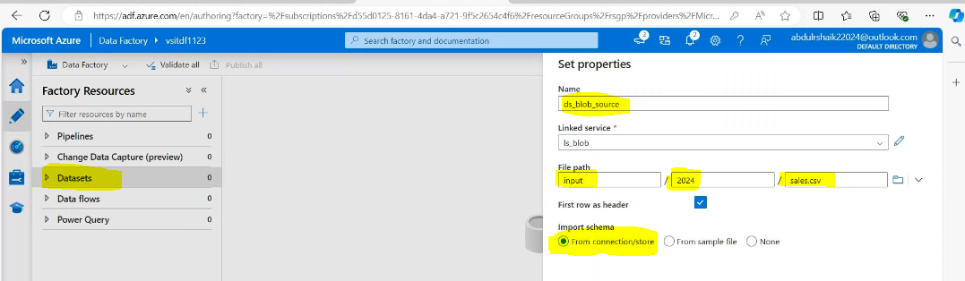
Create dataset for emp sink side:
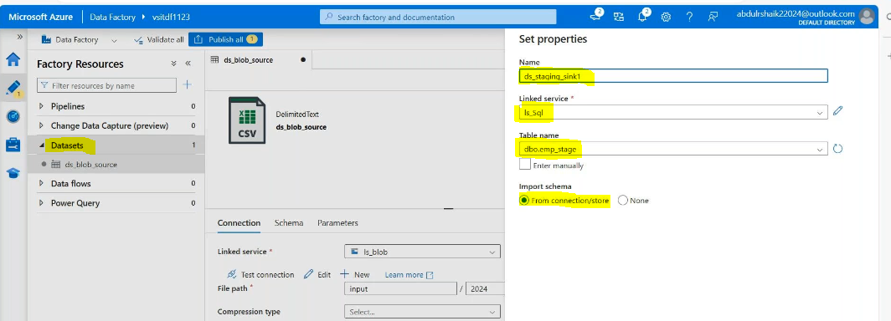
Create dataset for finale emp sink side:
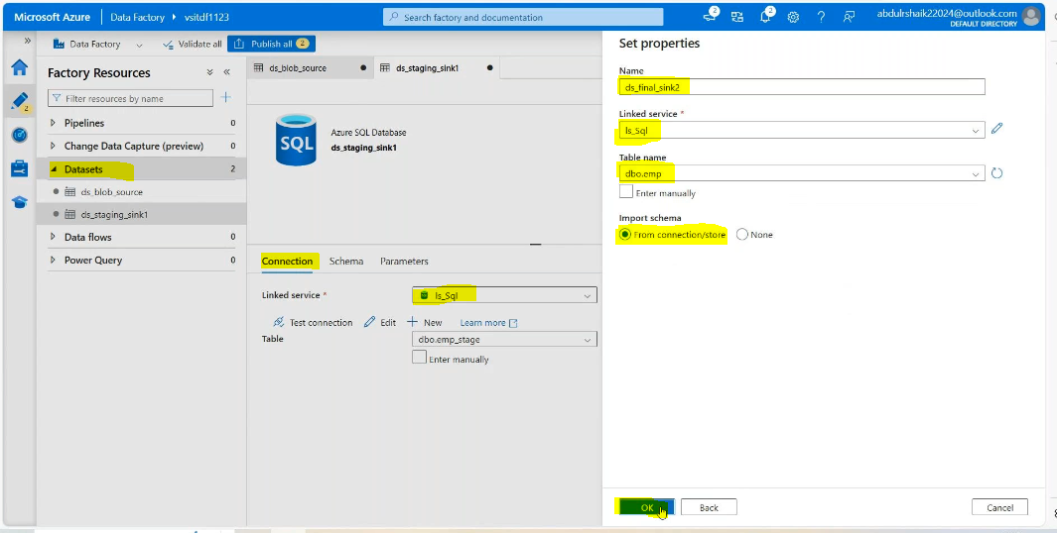
Then create pipeline : in that we are using 2 copy data activities like below
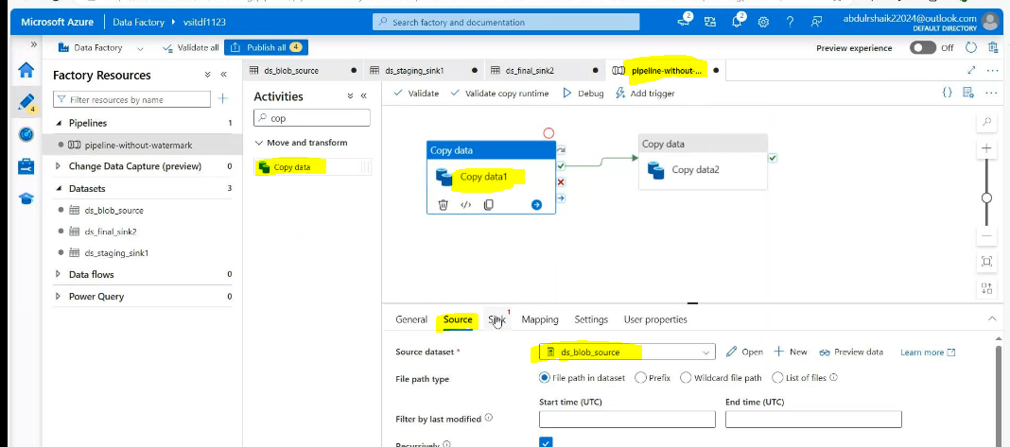
Sink side :copy data1

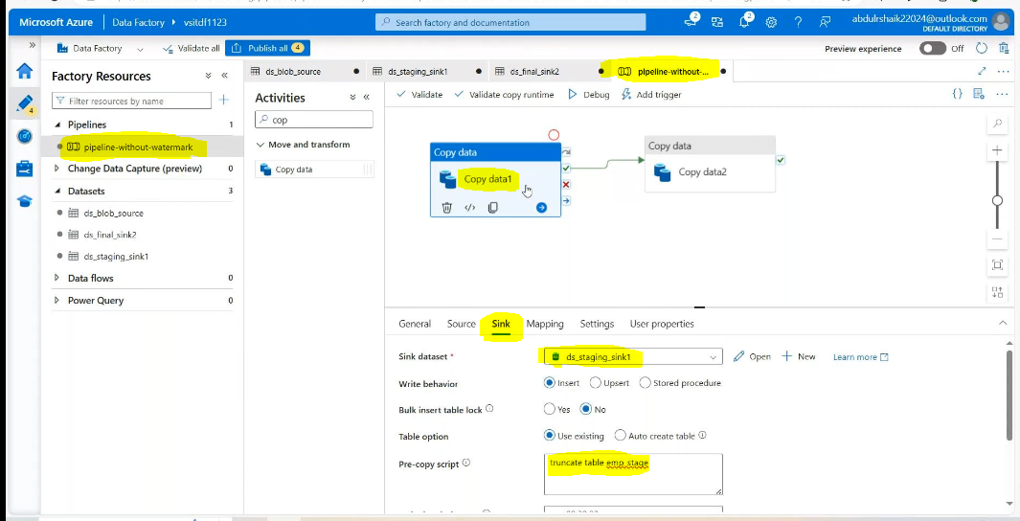
In copy data2:
Source side: create databse
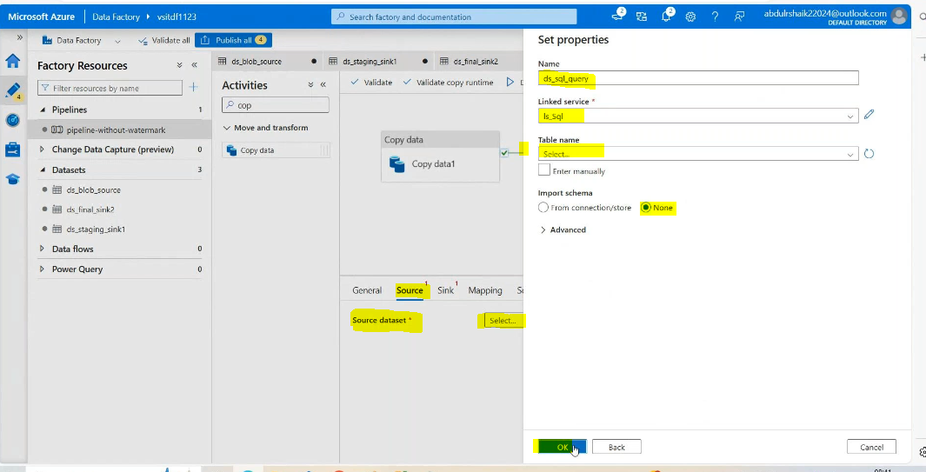

In query: we need to write query
select * from emp_stage where OrderDate>(select ISNULL(MAX(OrderDate),'1/1/2021 00:00:00')as maxdate from emp)
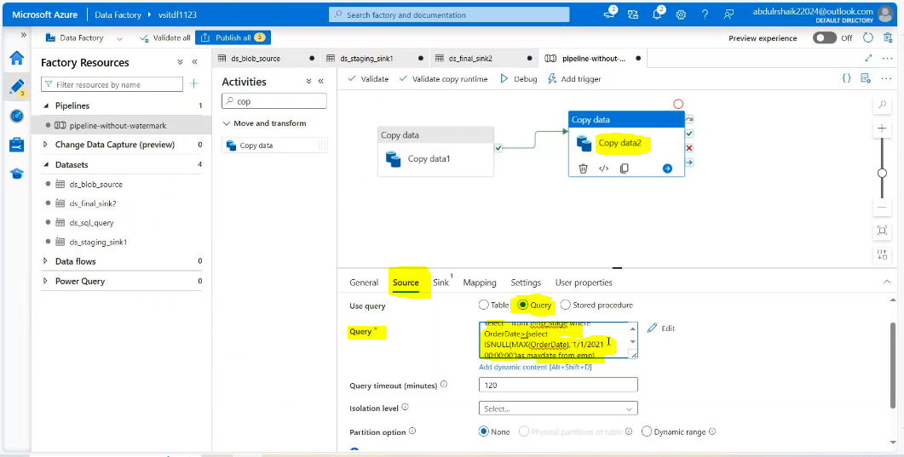

Validate & Debug:
Result:
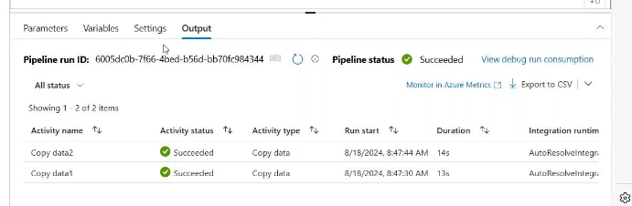
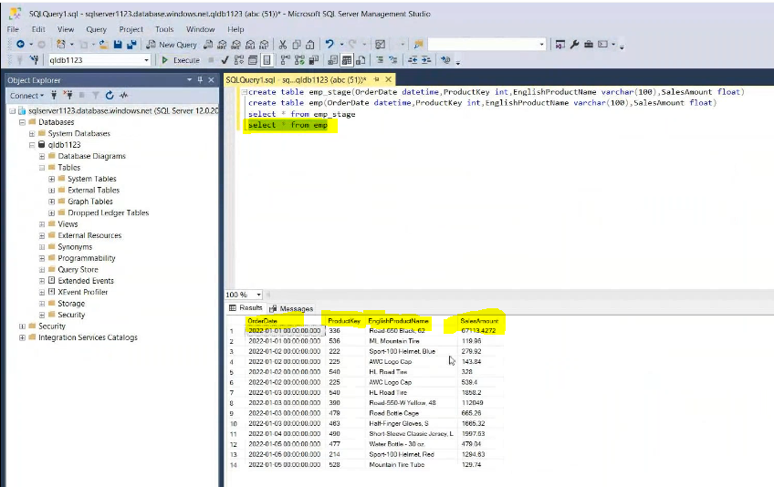
Then add new 3 new records 1 duplicate
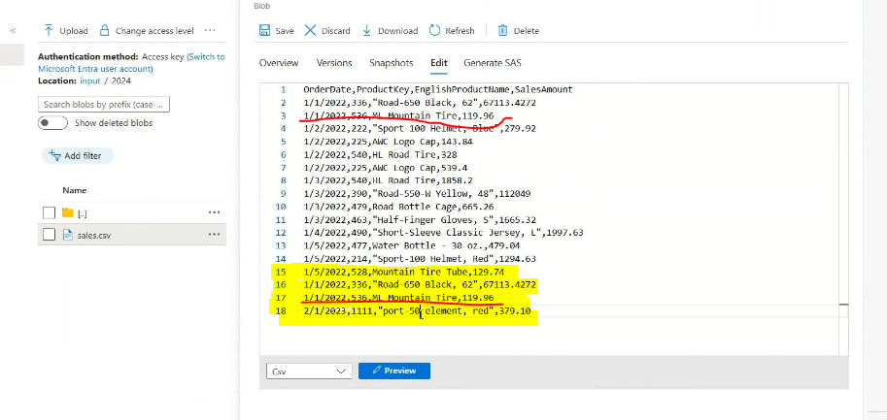
Save changes ,validate & Debug

